**Bootstrap 5 Forms**

<div class="container mt-3">

<h2>Stacked form</h2>

<form action="/action_page.php">

<div class="mb-3 mt-3">

<label for="email">Email:</label>

<input type="email" class="form-control" id="email" placeholder="Enter email" name="email">

</div>

<div class="mb-3">

<label for="pwd">Password:</label>

<input type="password" class="form-control" id="pwd" placeholder="Enter password" name="pswd">

</div>

<div class="form-check mb-3">

<label class="form-check-label">

<input class="form-check-input" type="checkbox" name="remember"> Remember me

</label>

</div>

<button type="submit" class="btn btn-primary">Submit</button>

</form>

</div>

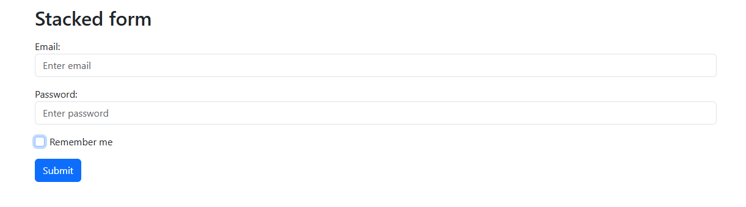

**Example : 2**

<div class="container mt-3">

<h2>Textarea</h2>

<p>Use the .form-control class to style textareas as well:</p>

<form action="/action_page.php">

<div class="mb-3 mt-3">

<label for="comment">Comments:</label>

<textarea class="form-control" rows="5" id="comment" name="text"></textarea>

</div>

<button type="submit" class="btn btn-primary">Submit</button>

</form>

</div>

